Transcription Translation

Tentative Lecture schedule Biochemistry of Medicinals I Phar 6151

Part 2 – Nucleic Acids

Instructor: Dr. Natalia Tretyakova, Ph.D. «hyperlink "mailto:Trety001@umn.edu"» - 6-3432

PDB reference correction and design Dr.chem., Ph.D. Aris Kaksis, Associate Prof. e-mail: ariska@latnet.lv

11-05 Introduction. DNA structure. Double helix, A, B, Z – form of DNA. Biophysical properties of DNA.
11-07 DNA topology. Supercoiling. Enzymes that change DNA: endonucleases, exonucleases
11-09 DNA replication. Polymerization reaction. E. Coli Pol I
11-12 DNA replication (continued). Initiation, elongation, and termination.
11-14 DNA repair. Mutations and cancer.
11-16 Transcription.
11-19 RNA structure. RNA synthesis in prokaryotes. RNA Pol. I.
11-21 RNA synthesis in eukaryotes. Transcription factors.
11-23 No class
11-26 Post-transcriptional modifications in eukaryotes. Review of DNA
11-28 Exam I. Nucleic acids. DNA structure and synthesis. Transcription. mRNA .
11-30 RNA splicing.
12-03 Translation. Genetic code. tRNA.
12-05 tRNA activation
12-07 Codon-anticodon interactions
12-10 Protein synthesis – translation
12-12 Protein synthesis – translocation. Drugs inhibiting protein synthesis
12-14 Review of tRNA, Protein synthesis. Course evaluation
12-17 Exam II. tRNA . Protein synthesis.

Course files: «hyperlink "http://www.pharmacy.umn.edu/resgrad/medchem/index.htm"»

Required reading: Stryer 4th ed Chapters 4 and 31

DNA Structure: Take Home Message

• DNA is a double stranded biopolymer containing repeating units of nitrogen base, deoxyribose sugar, and
phosphate.

• DNA can be arranged in 3 types of anti-parallel complementary strands which contain major and
minor grooves.
• DNA can adopt several topological forms.

There are enzymes that will cut DNA, ligate DNA and change the topology of DNA.

The Basics

Nucleic Acids

DNA RNA

Central Dogma of Biology

==========⇒ DNA =========⇒ RNA =========⇒ Proteins =========⇒ Cellular Action

Replication transcription translation =========⇒ Signal transduction

Why ?

Questions?

• How is DNA replicated?
• How is DNA synthesis initiated
• How is DNA fidelity maintained
• What kinds of DNA defects can occur?

Relevance:

• Cancer: ex., Xeroderma pigmentosum
• Genetic diseases: ex., cystic fibrosis
• Genetic typing: ex., drug metabolism
• Rational drug design: ex., antitumor drugs, pharmacogenetics
• Biotechnology: ex., growth hormones

DNA is Composed of Purine Nucleotides

Purine Nucleotides
Phosphate Nitrogen base (adenine, A) Guanine (G)
Deoxyadenosine 5’-phosphate (dAMP) Deoxyguanosine 5’-phosphate (dGMP)

DNA is Composed of Pyrimidine Nucleotides Pyrimidine Nucleotides

Phosphate Nitrogen base (cytosine, C) ()
Deoxycytidine 5’-phosphate (dCMP) Deoxy 5’-phosphate (dMP)

Preferred conformations of nucleobases and sugars in DNA

Anti conformation Syn conformation
3’ endo RNA 2’ endo (3’ exo) B-DNA

Nomenclature of nucleobases, nucleosides, and mononucleotides

Nucleobase | (Deoxy) nucleoside | Mononucleotide
Adenine (A)  Guanine (G)  ()  Cytosine (C)  () | Deoxyadenosine (dA)  Deoxyguanosine (dG)  Deoxy (d)  Deoxycytidine (dC) | Deoxyadenosine 5’-monophosphate  (5’-AMP)  Deoxyguanosine 5’-monophosphate  (5’-GMP)  Deoxy 5’-monophosphate  (5’-MP)  Deoxycytidine 5’-monophosphate  (5’-CMP)  5’-monophosphate (5’-MP)

Structural differences between DNA and RNA

DNA | RNA
Thymine T  2'-de-oxy-ribose | Uracil U  D-ribose

Nucleosides Must Be Converted to Triphosphates to be Part of DNA and RNA

Nucleosides are converted intracellularly to mono-, di- and tri-phosphates by nucleoside kinases:
Nucleoside Mono phosphate Di-phosphate ↓←ATP 4-
Tri-phosphate NTP 4-

DNA is Arranged 5’ to 3’ Connected by a Phosphate

C-A-G-

DNA secondary structure – double helix

J.Watson and F.Crick, 1950s- proposed DNA structure based on the following:

" DNA is the molecule of heredity (O.Avery, 1944)

" X-ray diffraction (R.Franklin and M. Wilkins)

" E. Chargaff (1940s) G ≡ C and A = in DNA

DNA Composed of Complementary Strands

DNA RNA Anti-parallel Strands of DNA

Base Pairing is Determined by Hydrogen Bonding

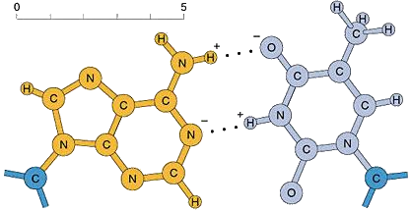A=
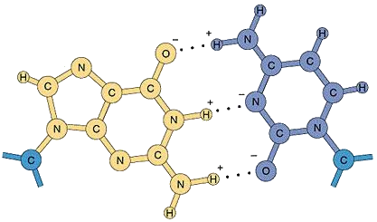G ≡ C
Double Helical DNA has Two Types of Grooves

Major groove Minor groove
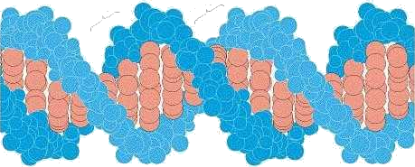

/ \
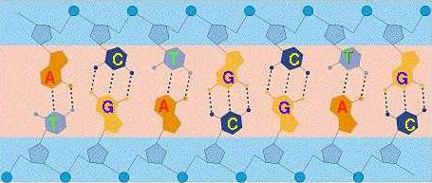

B-DNA 17 bp CPK colors 1D66.PDB

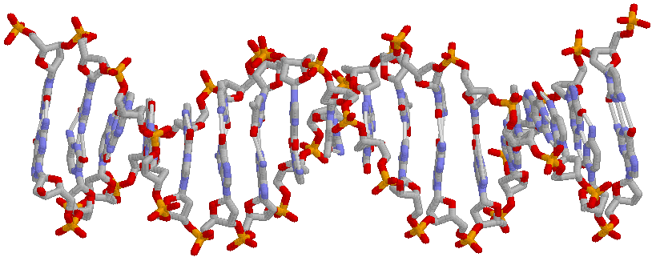
C≡G; G≡C; G≡C; A=;G≡C;C≡G;=A;G≡C;=A… 17 base pairs 1D66.PDB
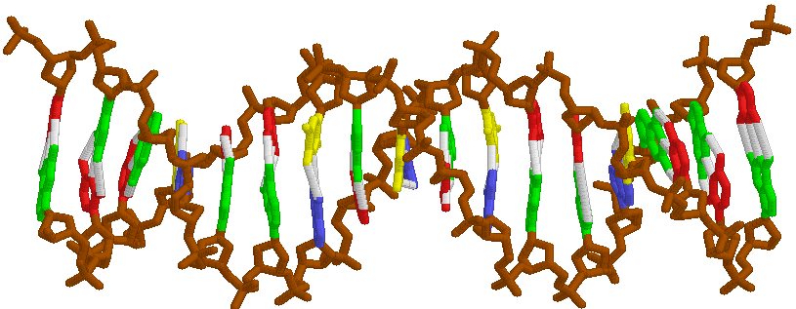

B-DNA

B-DNA = prevalent form in chromosomes

• right handed helix
• planes of bases are perpendicular | to the helix axis. 3.4 Å rise ↑ between base pairs
• Sugars are in 2' endo conformation. Bases are anti conformation.
• Bases have a helical twist of 36° 10.4 bases per helix turn (360º)
• Wide and deep major groove
• Narrow and deep minor groove

A-DNA 11 bp 2D47.PDB
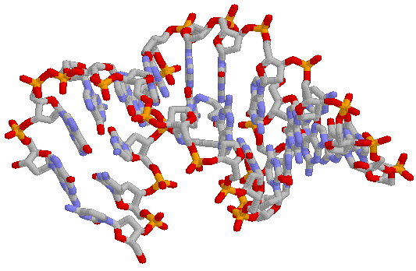

A-DNA 11 bp complete turn

A-DNA = prevalent form for dehydrated DNA; RNA-DNA hybrids - Right handed helix.
Glycosidic bonds 3' are anti Bases are tilted 23º with respect to helical axis.
2.56 Å helix rise ↑ between adjacent base pairs.
Differs from B-DNA due to changes in ribose puckering (3'-endo favored over 2’-endo)
11 bases per helix turn
Narrow and deep major groove
Very broad and shallow minor groove

Sugar puckering in different forms of double helix

2’ endo (3’ exo) B-DNA 3’ endo A-DNA

The size of major and minor groove is associated with the positions of
the bases relative to the helical axis
B-DNA A-DNA

Z-DNA 180D.PDB 6 baise pairs

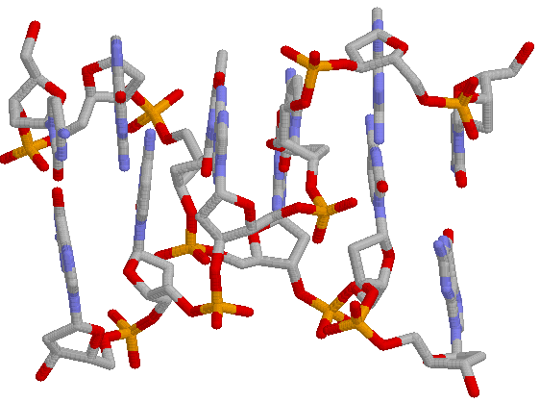
Z-DNA

Z-DNADNA = prevalent form for short oligonucleotides for sequences of alternating
pyrimidine (, C) and purines (G, A)
Left-handed helix
Glycosidic bond alternates between syn (purines) and anti (pyrimidines)
Backbone zig-zags, sugar pucker alternates between
2’ endo and 3’ endo
12 bases per helix turn
Left handed
Flat major groove
Narrow and deep minor groove
Possible conformations of DNA bases in NA

Anti conformation Syn conformation

DNA properties facilitate its recognition by proteins
The edges of base pairs displayed :

to DNA major and minor groove contain potential H-bond donors and acceptors:
N H O H
N = Nitrogen hydrogen bond acceptor
O = Oxygen hydrogen bond acceptor
H = Amino hydrogen bond donor

Hydrogen Bond donors and acceptors on Each Edge of a Base Pair

G≡C A=

DNA Characteristics

Physical properties of DNA

• UV absorbance (λmax = 260 nm)
• Denaturation and reassociation (recombination).

3. Negative charge >PO4(-) – can be separated by gel electrophoresis

