DNA Synthesis: Take Home Message
Instructor: Dr. Natalia Tretyakova, Ph.D. «hyperlink "mailto:Trety001@umn.edu"» - 6-3432

PDB reference correction and design Dr.chem., Ph.D. Aris Kaksis, Associate Prof. e-mail: ariska@latnet.lv

1) DNA synthesis is carried out by DNA polymerases with high fidelity.

2) DNA synthesis is characterized by initiation, priming and processive synthesis steps and
proceeds in 5’→ 3’ direction.

3) Modifications of DNA base pairs, if not repaired, can lead to mutations of the DNA sequence.

DNA Replication

Long before the structure of DNA was known, scientists wondered at the ability of organisms to create faithful copies of themselves and, later, at the ability of cells to produce many identical copies of large and complex macromolecules. Speculation about these problems centered around the concept of a template, a structure that would allow molecules to be lined up in a specific order and joined, to create a macromolecule with a unique sequence and function. The 1940s brought the revelation that DNA was the genetic molecule, but not until James Watson and Francis Crick deduced its structure did it become clear how DNA could act as a template for the replication and transmission of genetic information: one strand 1 is the complement of the other 2 second The strict base-pairing rules mean that each strand provides the template for a sister strand with a predictable and complementary sequence (see Figs 10-16, 10-17).
Besides maintaining the integrity of DNA sequences by DNA repair, all organisms must duplicate their DNA accurately before every cell division. DNA replication occurs at polymerization rates of about
500 nucleotides per second in bacteria and about 50 nucleotides per second in mammals. Clearly, the proteins that catalyze this process must be both 2 accurate and fast. Speed and accuracy are achieved by means of a multi-enzyme complex that guides the process and constitutes an elaborate
"replication machine".
The fundamental properties of the DNA replication process and the mechanisms used by the enzymes that catalyze it have proved to be essentially identical in all organisms. This mechanistic unity is a major theme as we proceed from general properties of the replication process, to E coli replication enzymes, and, finally, to replication in eukaryotes.

DNA Replication Is Governed by a Set of Fundamental Rules

DNA Replication Is Semi Conservative.

Base-pairing Underlies DNA Replication as well as DNA Repair

DNA templating is the process in which the nucleotide sequence of a DNA strand (or selected portions of a DNA strand) is copied by complementary base-pairing (A with or , and G with C) into a complementary nucleic acid sequence (either DNA or RNA). The process entails the recognition of each nucleotide in the DNA strand by an unpolymerized complementary nucleotide and requires that the two 2 strands of the DNA helix be separated, at least transiently, so that the hydrogen bond donor and acceptor groups on each base become exposed for base-pairing. The appropriate incoming single 1 nucleotides are thereby aligned for their enzyme-catalyzed polymerization into a new nucleic acid chain. In 1957 the first such nucleotide polymerizing enzyme, DNA polymerase, was discovered. The substrates for this enzyme were found to be de-oxy-ribo-nucleoside tri-phosphates, which are polymerized on a single-stranded DNA template. The stepwise mechanism of this reaction is the one previously illustrated in DNA Polymerase Enzyme in connection with DNA repair. The discovery of DNA polymerase led to the isolation of RNA polymerase, which was correctly inferred to use ribo-nucleoside tri-phosphates as its substrates.
During DNA replication each of the two 2 old DNA strands serves as a template for the formation of an entire new strand. Because each of the two 2 daughters of a dividing cell inherits a new DNA double helix containing one 1 old and one 1 new strand (see Figure 25-2), DNA is said to be replicated "semi conservatively" by DNA polymerase.
Each DNA strand serves as a template for the synthesis of a new strand, producing two new DNA molecules, each with one new strand and one old strand. This is semi conservative replication.
The hypothesis of semi conservative replication was proposed by Watson and Crick soon after publication of their 1953 paper on the structure of DNA, and was proved by ingeniously designed experiments carried out by Matthew Meselson and Franklin Stahi in 1957. Meselson and Stahi grew E. coli cells for many generations in a medium in which the sole nitrogen N source (NH4Cl) contained 15N, the "heavy" isotope of nitrogen N, instead of the normal, more abundant "light" isotope, 14N. The DNA isolated from these cells had a density about 1% greater than that of normal ['14N] DNA (Fig. 25-2a). Although this is only a small difference, a mixture of heavy [15N] DNA and light [14N]DNA can be separated by centrifugation to equilibrium in a cesium chloride CsCl density gradient.
The E. coli cells grown in the 15N medium were transferred to a fresh medium containing only the 14N isotope, where they were allowed to grow until the cell population had just doubled. The DNA isolated from these first-generation cells formed a single 1 band in the CsCl gradient at a position indicating that the
double-helical DNAs of the daughter cells were hybrids containing one 1 new 14N strand and
one 1 parental 15N strand (Fig. 25-2b).
This result argued against conservative replication, an alternative hypothesis in which one 1 progeny DNA molecule would consist of two 2 newly synthesized DNA strands and the other would contain the two 2 parental strands; this would not yield hybrid DNA molecules in the Meselson-Stahl experiment. The semi conservative replication hypothesis was further supported in the next step of the experiment (Fig. 25-2c). Cells were again allowed to double 2 in number in the 14N medium. The isolated DNA product of this second 2 cycle of replication exhibited two 2 bands in the density gradient, one with a density equal to that of light DNA and the other with the density of the hybrid DNA observed after the first cell doubling.

DNA extracted and centrifuged to equilibrium in CsCl density gradient

Figure 25-2. The Meselson-Stahl experiment.
(a) Cells were grown for many generations in a medium containing only heavy nitrogen, 15N, so that
all the nitrogen N in their DNA was 15N, as shown by a single 1 band (blue) when centrifuged in
a CsCl density gradient.
(b) Once the cells had been transferred to a medium containing only light nitrogen, 14N, cellular DNA isolated after one generation equilibrated at a higher position in the density gradient (purple band).
(c) Continuation of replication for a second 2 generation yielded two 2 hybrid DNAs and two 2 light DNAs (red), confirming semi conservative replication.

Possible Models for DNA Replication

Conservative replication Dispersive replication Semiconservative replication

Possible Models os DNA Replication
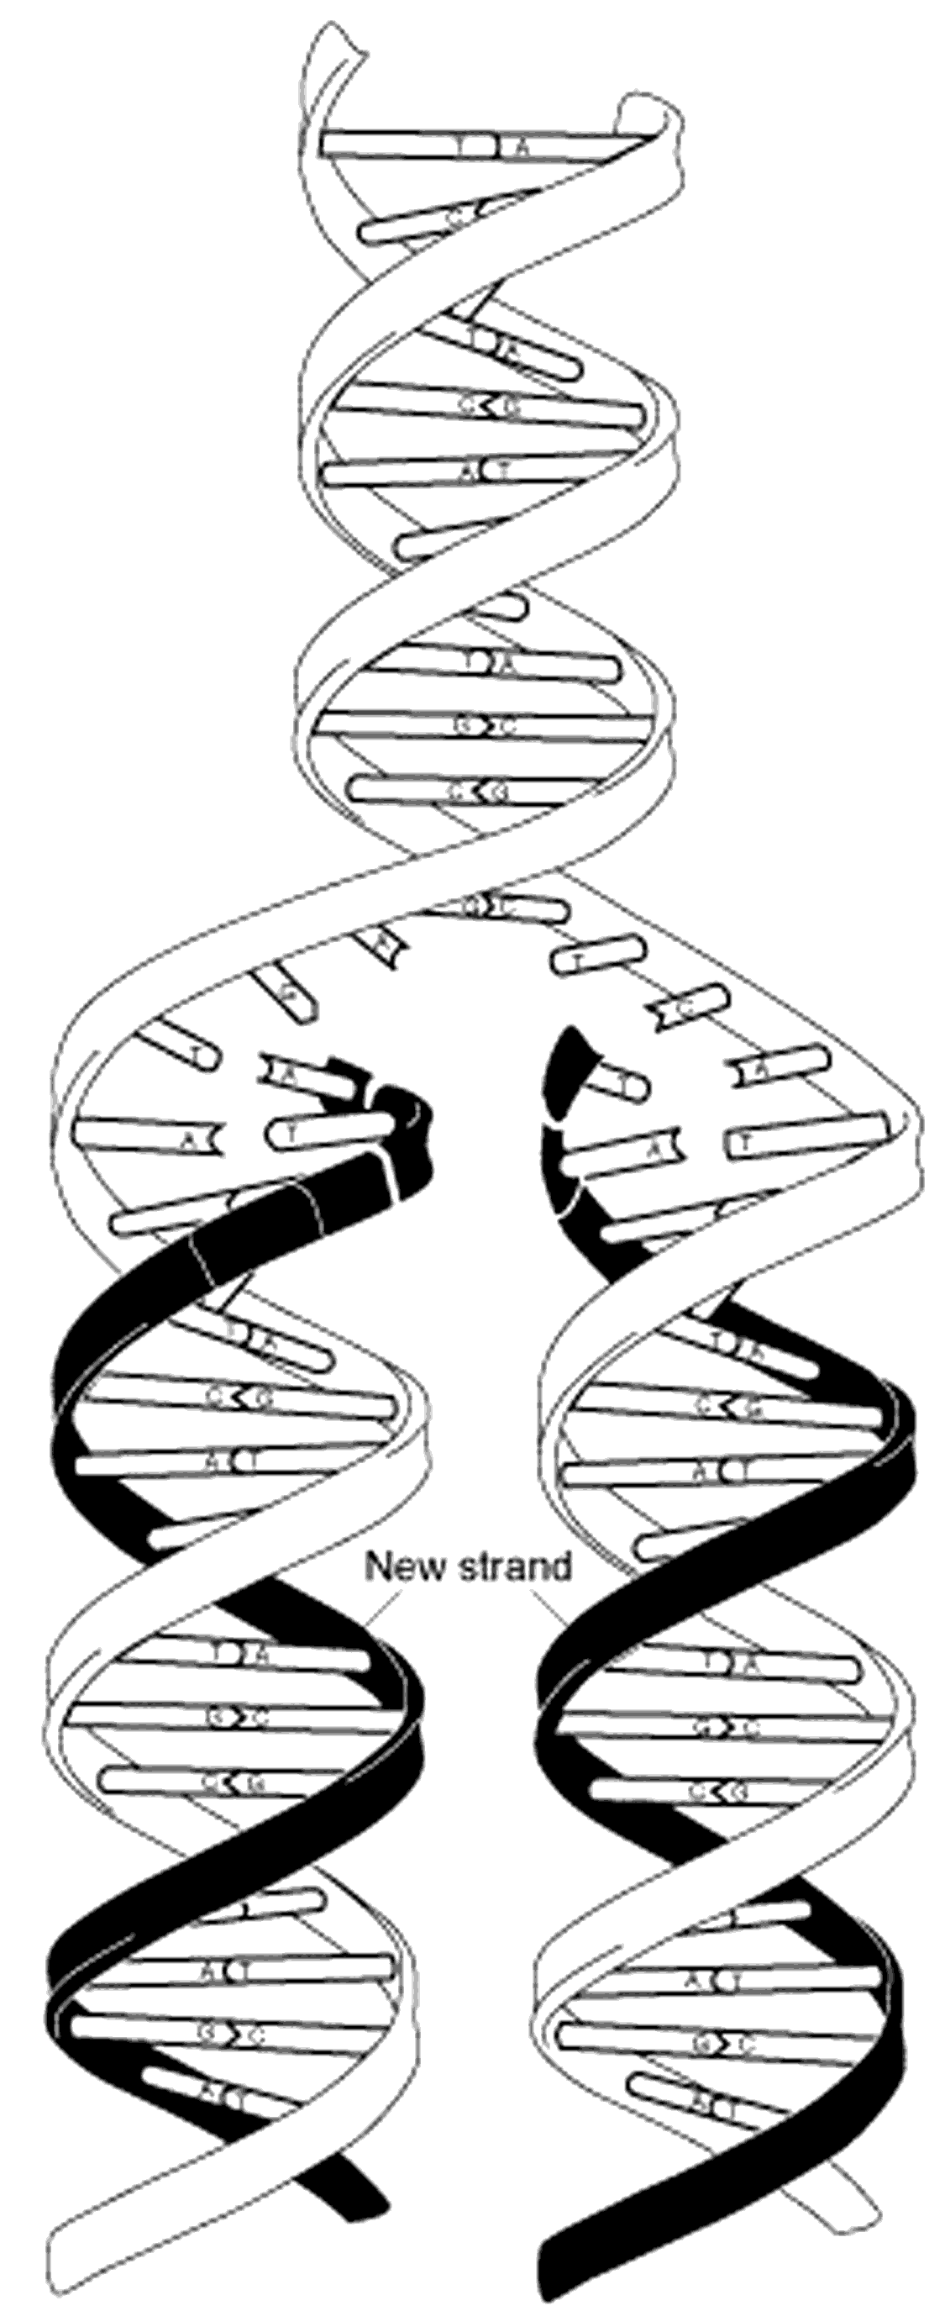 Meselson, Stahl 1958

DNA Polymerization

(DNA)n bases + dNTP ⎯→ (DNA)(n+1) bases + PPi

E. coli DNA Polymerase I
Klenow Fragment
↑↑↑↑↑↑↑↑↑↑↑↑↑↑↑↑↑↑↑↑↑↑

N-–C
36 kDa 67 kDa

• large cleft for duplex DNA
• flexible finger and thumb region for positioning of duplex and dNTPs polymerase site
• 3'→ 5' and 5'→ 3' exonuclease catalytic sites

3` → 5` Exonuclease 5`→ 3` Exonuclease

Typical Polymerase Structure

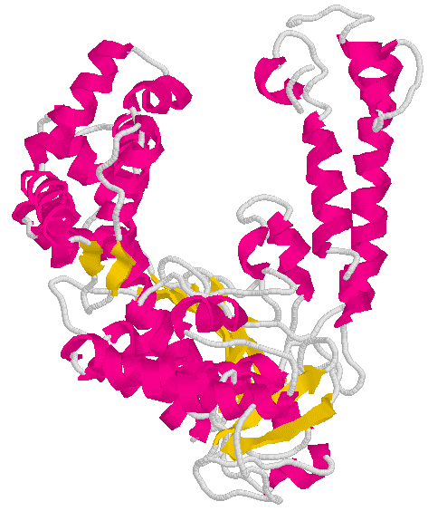

KLENOW Polymerase

Typical Polymerase Structure

Exonuclease Domain

