Instructor: Dr. Natalia Tretyakova, Ph.D. «hyperlink "mailto:Trety001@umn.edu"» - 6-3432
PDB reference correction and design Dr.chem., Ph.D. Aris Kaksis, Associate Prof. e-mail: :ariska@latnet.lv

Template

Figure 1. Two – metal – ion mechanism.

E. Coli DNA Polymerases

Characteristic Pol I Pol II Pol III
Mol. Weight (Da) 103,000 88,000 900,000
Number of polypeptides 1 4 10
rate (nucleotides/sec) 16-20 7 250-1000
3'→ 5' exonuclease yes yes yes
5'→ 3' exonuclease yes no no
function Primer removal, unknown Major
gap filling replicative polymerase

DNA Polymerization Has Three Stages

1) Initiation

2) Priming

3) Processive Synthesis

DNA Polymerization: Initiation

• DNA replication begins at a specific site.

• Example: oriC site from E. coli.
• 245 bp out of 4,000,000 bp
• contains tandem array of three 13-mers; GACNN
• GAC common motif in oriC
• A bp are common to facilitate unwinding

Initiation of DNA Polymerization

Tandem Array
(13-Mer Seq. A- Rich) dna A
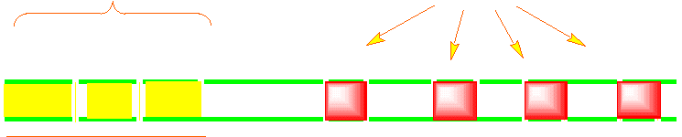
Ori C dna A protein unwinds oriC at several sites

Enzymes involved in the initiation of DNA Polymerization

Enzyme Function

dna A recognize replication origin and unwinds it at several sites

Helicase (dnaB) unwinding of ds DNA

DNA gyrase generates (-) supercoiling that compensates for the (+)
supercoiling generated in front of the replication fork

SSB stabilize unwound ssDNA

Primase a RNA polymerase that generates RNA primer.

Priming of DNA Polymerization Primer Synthesis and removal

3' 5'
↓ Primase
3' 5'
5' 3'
RNA primer + ↓ DNA Pol III
3' 5'
5' ⎯→ 3'
↓ DNA Pol I
DNA strand 3' 5'
5' 3'
degraded ← primer + ↓ DNA Ligase
3' 5'
5' 3'

DNA Polymerization

Processive Synthesis
The synthesis of DNA in E. Coli is carried out by the DNA polymerase III holoenzyme.

• Extremely high processivity; once it combines with the DNA and starts it
does not come off until finished.
• Tremendous catalytic potential; 1000 nucleotides per sec.
• Low error rate (high fidelity) 1 error per 10,000,000,000

α subunit is the polymerase
ε subunit is the 3' → 5' exonuclease
β subunit provides a tight clamp for sliding DNA through

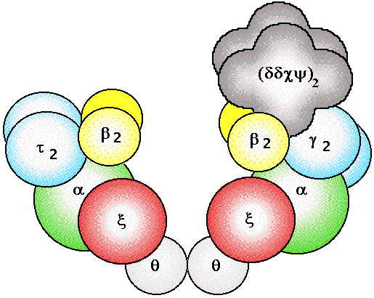Pol III

Pol III Pol III + DNA

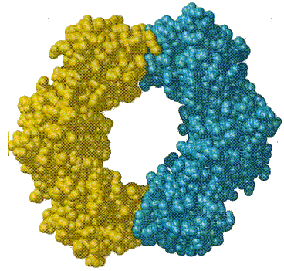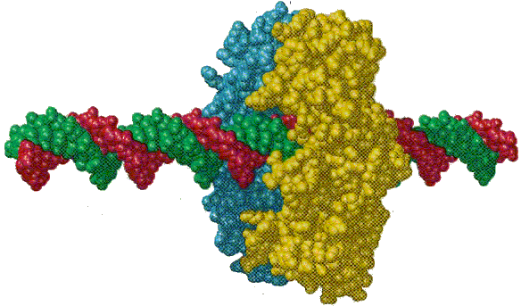
⏐⎯ 50 Å ⎯ ⎯ ⏐
DNA SynthesisDNA Synthesis
5' 3'
3' 5' 3' 5'

