Protein Synthesis Part 3: Take Home Message
Instructor: Dr. Natalia Tretyakova, Ph.D.
PDB reference correction and design Dr. chem., Aris Kaksis, assistant Professor

Required reading: Stryer 4th Ed. Ch. 34 p. 888-908

1) Translation always proceeds by reading the mRNA sequence from the 5’ to the 3’ end.

2) Amino acids AA are assembled in to proteins with the first amino acid AA1 having a free amino group
(N-terminus) –NH2 and the last having a free carboxylate –COO- (C-terminus) (N→C)

3) Synthesis of the protein is processive and contains 3 steps;
a) initiation, b) elongation and c) termination

Overall Ribosome Structure: Translation Machine

70S

Large Subunit S50
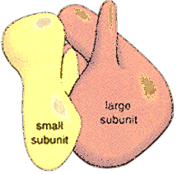 Small Subunit S30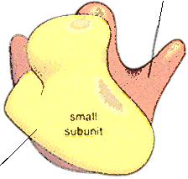
Prokaryotic Ribosomes 70S
Two tRNA binding sites
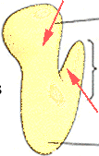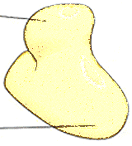

Peptidyl ↓ transferase
ridge ↓ ↓GTPase back
50 S
Exit site ↑ Prokaryotic Ribosomes 70S

Tertiary 3° structure of 16S rRNA

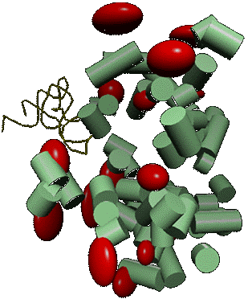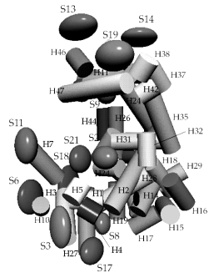

Overview of Translation in prokaryotes

Several ribosomes simultaneously translate a messenger RNA

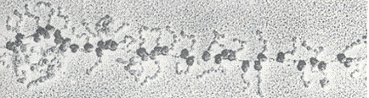
Five 5 and 35 ribosomes read the same mRNA sequentially
Growing polypeptide chains Complete polypeptide
5’ initiator codon AUG 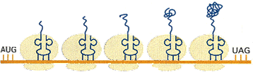
Ribosome movement ⎯⎯⎯⎯⎯⎯⎯⎯⎯⎯⎯⎯→

Translating the Message

DNA 5'-ATG-GCC-TTT-GAT-TCT-AAA-TAA-3'

mRNA 5'-AUG-GCC-UUU-GAU-UCU-AAA-UAA-3'

Protein N- Met Ala Phe Asp Ser Lys Stop –C

Write the sequence in a polypeptide translated from the following mRNA:

RNA 5'-GGA-GGA-GUA-AGU-UGU-3'

Protein N- Gly -Gly - Val - Ser - Cys –C

Table 1. The genetic code. for mRNA Ψ Genetic Code

1st position | 2nd position |  |  |  | 3rd position
(5' end) ↓ | U | C | A | G | (3' end) ↓
U | Phe  Phe  Leu  Leu | Ser  Ser  Ser  Ser | Tyr  Tyr  STOP  STOP | Cys  Cys  Sel-Cys  Trp | U  C  A  G
C | Leu  Leu  Leu  Leu | Pro  Pro  Pro  Pro | His  His  Gln  Gln | Arg  Arg  Arg  Arg | U  C  A  G
A | Ile  Ile  Ile  Met init | Thr  Thr  Thr  Thr | Asn  Asn  Lys  Lys | Ser  Ser  Arg  Arg | U  C  A  G
G | Val  Val  Val  Val | Ala  Ala  Ala  Ala | Asp  Asp  Glu  Glu | Gly  Gly  Gly  Gly | U  C  A  G

Sets of three 3 nucleotides (codons) in an mRNA molecule are translated into amino acids AA in the course of protein synthesis according to the rules shown. The codons GUG and GAG, for example, are translated into valine and glutamic acid, respectively. Note that those codons with U or C as the second 2 nucleotide tend to specify the more hydrophobic amino acids AA.

Prokaryotic mRNAs often are polycistronic (encode more than one polypeptide)

(a) transcription in the presence of an inducer
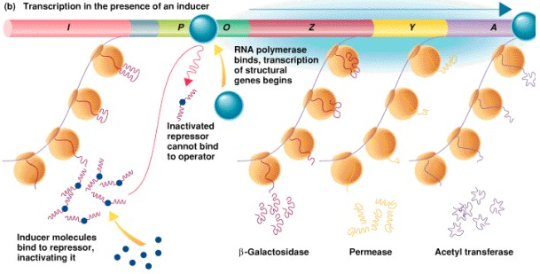
RNA polymerase binds, transcription of structural genes begins
Inactivated repressor cannot bind to operator
Inducer molecules bind to repressor, inactivating it
Beta-Galactosidase Permease Acetyl transferase

Translation: Formyl Methionine

tRNAf Initiator tRNA

Initiation of Translation: Ribosomal Binding Site

Shine-Delgarno 5’ cap AGGAGGU
16S 3’ UCCUCC A 5’
││││││ │
mRNA 5’ GAUUCCU AGGAGGU AUG GCC UUU 3’
Protein start Met Ala Phe

Initiating AA tRNA is Met;
Initiator tRNA is Met-tRNA;
Initiatior signal is AUG – no Shine-Delgarno sequence;
40S subunit-Met-tRNA; -initiation factors complex binds 5’ cap AGGAGGU and
scans mRNA for the nearest AUG

Protein synthesis: Termination

When the ribosome encounters a stop codon (shown as the triplet), there is no tRNA attracted and the ribosome separates and leaves the mRNA.
5’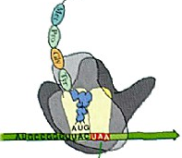3’ 5’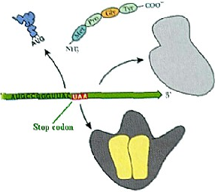
Stop codon Stop codon

tRNA binding sites inside the E. coli Ribosome

large subunit tRNA tRNA
Small subunit mRNA location

Large ribosome subunit: PDB 1FFK Large Ribosome Subunit
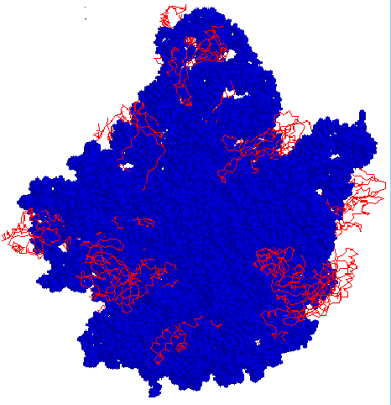
Crown”view with RNAs blue, in spacefill; proteins red, as bacjbone.

Protein factors involved in translation
Initiation Role
IF 1, 3 Assembly of initiation complex
IF 2 Brings initiator fMet-tRNAf

Elongation
EF-Tu Carries tRNAs to the A ribosomal site
EF-Ts Interchange EF-Tu with GTP
EF-G Translocation

Termination
RF-1 Release factor (UAA, UAG)
RF-2 Release factor (UAA, UGA)
RF-3 GTPase, promotes release

Initiation of protein synthesis

Ribosomal Binding Site

30S 30S•IF1•IF2•IF3
fMet fMet
5’mRNA 5’ mRNA
S.D.

Protein synthesis: Elongation
Large ribosome binds and then the next tRNA binds at A site
Peptide bond forms: complex then moves to P site
Another tRNA moves into the A site in order to add another amino acid AA to the peptide chain NH3+
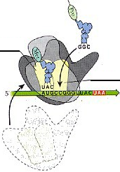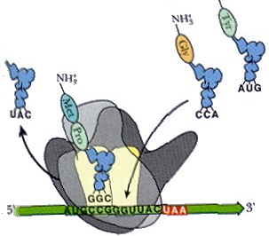

Transfer of aa-tRNA to Ribosome

[Tu] →→→ [AA-tRNA]

Peptidyl Transferase
P A

Translocation
NH3+.

Ribosome Synthesis of Polypeptide
A = Acceptor
P = Product
E = Exit

E P A E P A
E P A E P A E P A
↓⎯⎯→ Continued Peptide Synthesis

Termination of Peptide Synthesis by RF1 and RF2

E P A
←⎯ C

Termination of Translation

mRNA 5'+ ⇒

Ribosome t-RNA Binding Sites
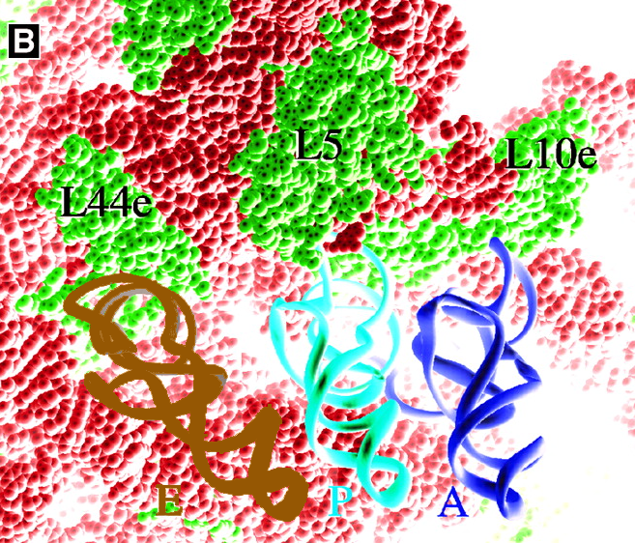
A Steitz, 2000 B

Ribosome Peptidyl Transferase Steitz, 2000

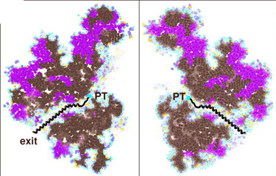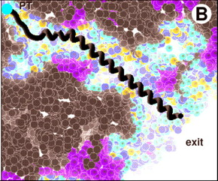
A B
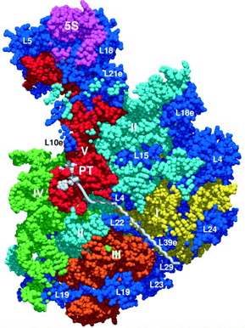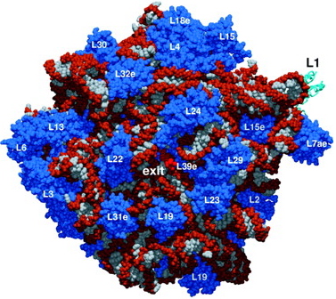
C D
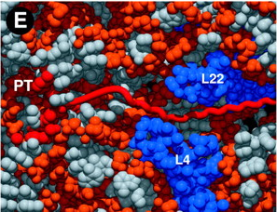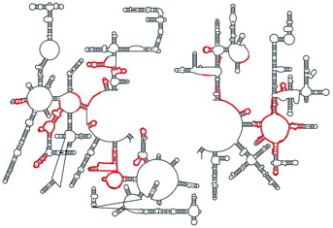
E F

Protein synthesis as target for drug design

• Can target various steps in protein synthesis: initiation, elongation, translocation
• Many natural antibiotics – leads for drug design

• mechanisms of selective toxicity:
Selective permeability of bacterial cell wall and membranes
Differences in structure and mechanism of bacterial protein synthesis and eukaryotes – can target bacteria

• mechanisms of resistance:
Lowered ↓ permeability of cytoplasmic membrane
Change in shape of the ribosomal binding site
Enzymic modification by a plasmid-borne gene
Drugs that Target Translation

Antibiotics interfere with the processes of translation by several different mechanisms.

←⎯⎯⎯⎯⎯⎯
↓

↓
←⎯⎯⎯⎯⎯⎯⎯⎯
↓
←⎯⎯⎯⎯⎯⎯
↓⎯⎯→ Release of uncharged tRNA
←⎯⎯⎯⎯⎯⎯
↓

↓
←⎯⎯⎯⎯⎯⎯⎯⎯⎯⎯
↓

↓

Amino-acyl-tRNA Puromycin inhibits chain elongation Puro-mycin

P site A site
3’ end pepptidyl-tRNA Puro-mycin
Tetracycline
Inhibits binding of tRNA
Chloramphenicol

Protein Synthesis Part 2: Take Home Message

1) Translation always proceeds by reading the mRNA sequence from the 5’ to the 3’ end.

2) Amino acids are assembled in to proteins with the first amino acid having a free amino group
(N-terminus) and the last having a free carboxylate (C-terminus).

3) Synthesis of the protein is processive and contains steps;
a) initiation, b) elongation and c) termination

4) Antibiotic drugs target various steps of protein synthesis in bacteria

