Transcription Transcription Translation
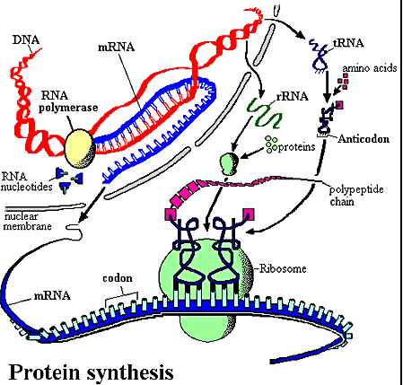Translation

Protein Synthesis Part 1: Take Home Message

Required reading: Stryer Ch. 34, p. 875-888 Ch. 33 p. 849-850

1) Translation of the genetic code is dependent on three base words that correspond to a single
amino acid AA (codons).

2) The mRNA message is read by tRNA through the use of a three base complement to the three 3
base word (anticodon).

3) A specific amino acid AA is conjugated to a specific tRNA.

4) Amino acid AA side chain size, hydrophobicity and polarity govern the ability of tRNA synthetases
to conjugate a specific three 3 base message with a specific amino acid AA.

Table 1. The genetic code. for mRNA Ψ Genetic Code

1st position | 2nd position |  |  |  |  | 3rd position
(5' end)−−> |  | C | A | G | (3' end)-->
 | Phe  Phe  Leu  Leu | Ser  Ser  Ser  Ser | Tyr  Tyr  STOP  STOP | Cys  Cys  STOP SelenoCys Trp Mitochondria  Trp | C  A  G
C | Leu  Leu  Leu  Leu | Pro  Pro  Pro  Pro | His  His  Gln  Gln | Arg  Arg  Arg  Arg | C  A  G
A | Ile  Ile  Ile  Met init | Thr  Thr  Thr  Thr | Asn  Asn  Lys  Lys | Ser  Ser  Arg  Arg | C  A  G
G | Val  Val  Val  Val | Ala  Ala  Ala  Ala | Asp  Asp  Glu  Glu | Gly  Gly  Gly  Gly | C  A  G

Sets of three 3 nucleotides (codons) in an mRNA molecule are translated into amino acids AA in the course of protein synthesis according to the rules shown. The codons GG and GAG, for example, are translated into valine and glutamic acid, respectively. Note that those codons with or C as the second 2 nucleotide tend to specify the more hydrophobic amino acids AA.

Structure of Transfer RNA

Di-hydro-uridine (DHU) Anti Codon Pseudo-uridine (Ψ)

Classes of Aminoacyl-tRNA Synthetases

• Class I: Arg, Cys, Gln, Glu, Ile, Leu, Met, Trp, Tyr, Val (Generally the Larger Amino Acids)
• Class II: Ala, Asn, Asp, Gly, His , Lys, Phe, Ser, Pro, Thr (Generally the smaller amino acids)
Charged tRNA -76

tRNA Activation by aminoacyl tRNA synthases

1. Amino-acyl-AMP formation
2. Aminoacyl transfer to the appropriate tRNA + AMP1-

tRNA Recognition by Synthetases

• Specific recognition of the anticodon; ex. an change the anticodon for tRNATrp to
that for methionine and get good acylation by tRNAMet.
•Stem sequences can be crucial; ex. tRNAAla depends on GC at position 3:70 doesn't care what the codon is.
• Both the stem regions and anticodon are needed; ex. tRNA Gln.

tRNA Recognition by Synthetases

tRNA-Ala tRNA-Phe Trna- Ser

tRNA Recognition by Synthetases
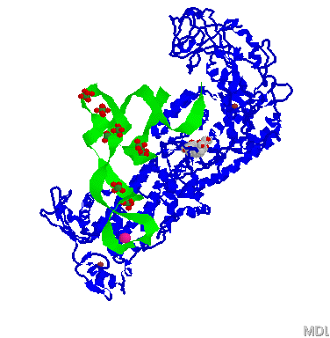
Anticodon Recognition ↑

tRNA Synthetase Proofreading Ile

Large Smaller Large Smaller
Acylation Site Hydrolytic Site Acylation Site Hydrolytic Site
← Difference →
Correct Acylation Mis-acylation
tRNA Synthetase Proofreading Val

Hydrophobic Polar Hydrophobic Polar
Acylation Site Hydrolytic Site Acylation Site Hydrolytic Site
← Difference →
Correct Acylation Mis-acylation

How do we go from mRNA to Protein?

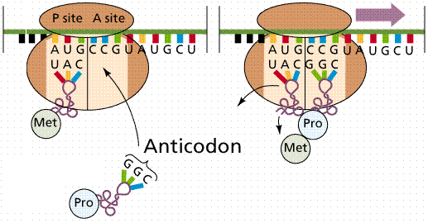
Incoming tRNA
Table 1. The genetic code. for mRNA Ψ Genetic Code

1st position | 2nd position |  |  |  |  | 3rd position
(5' end)−−> |  | C | A | G | (3' end)-->
 | Phe  Phe  Leu  Leu | Ser  Ser  Ser  Ser | Tyr  Tyr  STOP  STOP | Cys  Cys  STOP SelenoCys Trp Mitochondria  Trp | C  A  G
C | Leu  Leu  Leu  Leu | Pro  Pro  Pro  Pro | His  His  Gln  Gln | Arg  Arg  Arg  Arg | C  A  G
A | Ile  Ile  Ile  Met init | Thr  Thr  Thr  Thr | Asn  Asn  Lys  Lys | Ser  Ser  Arg  Arg | C  A  G
G | Val  Val  Val  Val | Ala  Ala  Ala  Ala | Asp  Asp  Glu  Glu | Gly  Gly  Gly  Gly | C  A  G

Sets of three 3 nucleotides (codons) in an mRNA molecule are translated into amino acids AA in the course of protein synthesis according to the rules shown. The codons GG and GAG, for example, are translated into valine and glutamic acid, respectively. Note that those codons with or C as the second 2 nucleotide tend to specify the more hydrophobic amino acids AA.

Wobble pairing rules
5’ anticodon base 3’ codon base

C G

A

A or G

G C or

I , C, or A
tRNA Anticodon-Codon Recognition

Anticodon 3’ – C – G – I – 5’ 3’ – C – G – I – 5’ 3’ – C – G – I – 5’
Codon 5’ – C – G – – 3’ 5’ – C – G – C – 3’ 5’ – C – G – A – 3’

Anticodon 3’ – C – G – G – 5’ 3’ – C – G – G – 5’
Codon 5’ – C – G – – 3’ 5’ – C – G – C – 3’

Anticodon 3’ – C – G – – 5’ 3’ – C – G – – 5’
Codon 5’ – C – G – A – 3’ 5’ – C – G – G – 3’

Anticodon 3’ – C – G – C – 5’ 3’ – C – G – A – 5’
Codon 5’ – C – G – G – 3’ 5’ – C – G – – 3’

tRNA Anticodon-Codon Recognition

Adenosine Inosine Guanosine

Anticodon 3’ – C – G – I – 5’ 3’ – C – G – I – 5’ 3’ – C – G – I – 5’
Codon 5’ – C – G – C – 3’ 5’ – C – G – A – 3’ 5’ – C – G – – 3’

I------C base pair I-----A base pair I----- base pair

Nonsense suppression

Table 1. The genetic code. for mRNA Ψ Genetic Code

1st position | 2nd position |  |  |  | 3rd position
(5' end)−−> |  | C | A | G | (3' end)-->
 | Phe  Phe  Leu  Leu | Ser  Ser  Ser  Ser | Tyr  Tyr  STOP  STOP | Cys  Cys  STOP SelenoCys Trp Mitochondria  Trp | C  A  G
C | Leu  Leu  Leu  Leu | Pro  Pro  Pro  Pro | His  His  Gln  Gln | Arg  Arg  Arg  Arg | C  A  G
A | Ile  Ile  Ile  Met init | Thr  Thr  Thr  Thr | Asn  Asn  Lys  Lys | Ser  Ser  Arg  Arg | C  A  G
G | Val  Val  Val  Val | Ala  Ala  Ala  Ala | Asp  Asp  Glu  Glu | Gly  Gly  Gly  Gly | C  A  G

Sets of three 3 nucleotides (codons) in an mRNA molecule are translated into amino acids AA in the course of protein synthesis according to the rules shown. The codons GG and GAG, for example, are translated into valine and glutamic acid, respectively. Note that those codons with or C as the second 2 nucleotide tend to specify the more hydrophobic amino acids AA.

Protein Synthesis Part 2: Take Home Message

1) Translation always proceeds by reading the mRNA sequence from the 5’ to the 3’ end.

2) Amino acids are assembled in to proteins with the first amino acid having a free amino group
—NH3+ (N-terminus) and the last having a free carboxylate—COO— (C-terminus).

3) Synthesis of the protein is processive and contains steps;
a) initiation, b) elongation and c) termination

Overall Ribosome Structure: Translation Machine
• tRNA site, peptidyl transferase, GTPase and Exit site

DNA 5'-ATG---GCC---GA--C-AAA--AA- 3’ Translating the Message
RNA 5' -AG--GCC---GA--C-AAA--AA--3’
Protein N- Met Ala Phe Asp Ser Lys Stop -C Overview of Translation

1) Translation of the genetic code is dependent on three base words
that correspond to a single amino acid.

2) The mRNA message is read by tRNA through the use of a three base complement to
the three 3 base word.

3) A specific amino acid is conjugated to a specific tRNA (three base word).

4) Amino acid side chain size, hydrophobicity and polarity govern the ability of tRNA synthetases to
conjugate a specific three base message with a specific amino acid AA.

